**Unit 10 Circles Review Sheet**

**Topic #1: Circle Arcs, Arc Length, and Sector Area**

1. 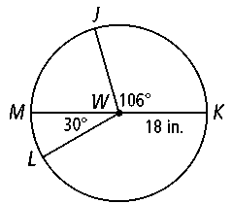Find the measure of arc JMK.
2. Find the arc length of JK.
3. Find the area of sector JWK.

**Topic #2: Tangents   
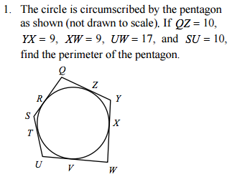 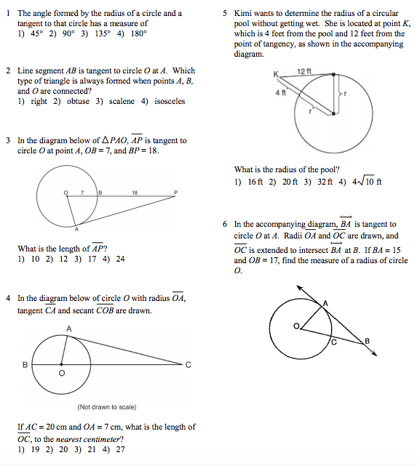**

**Topic #3: Chords**

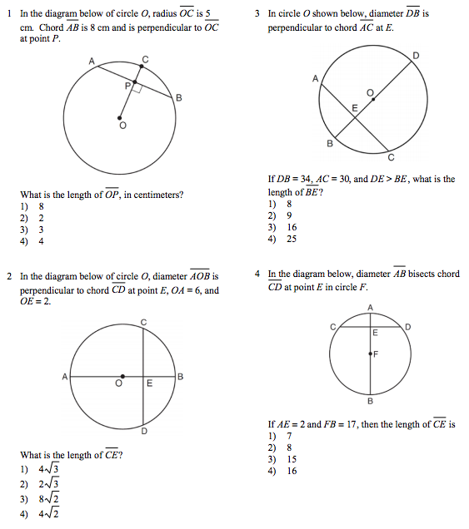 

**Topic #4: Angles created in Circles**

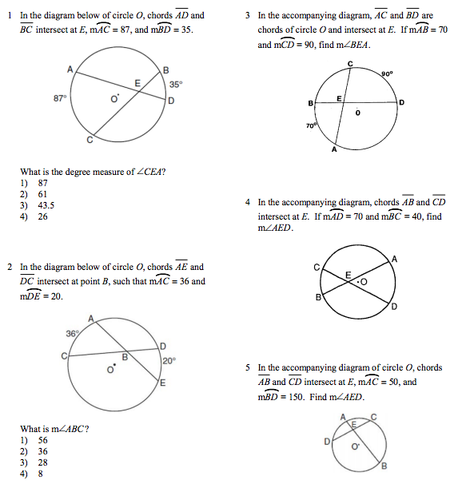 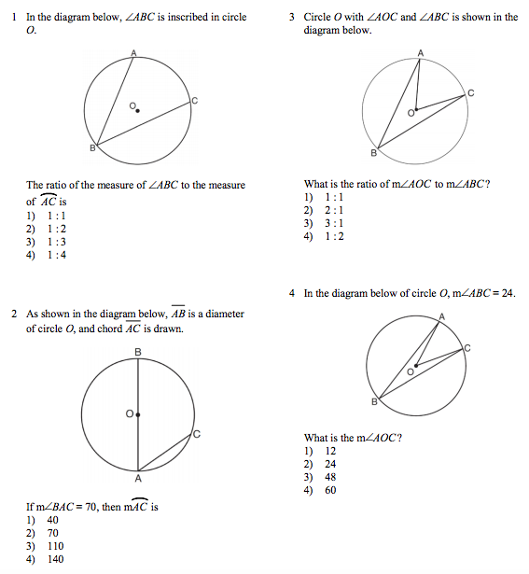

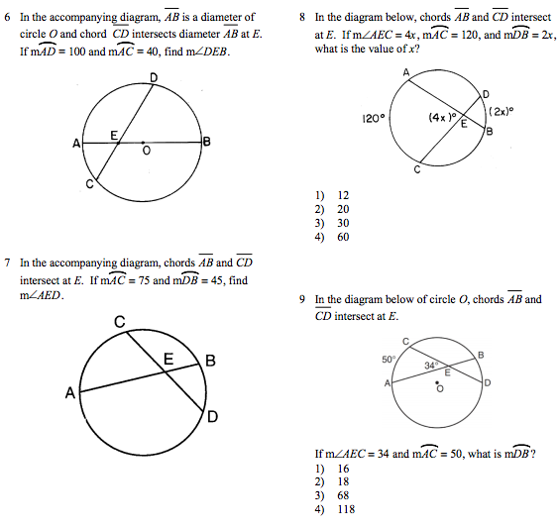 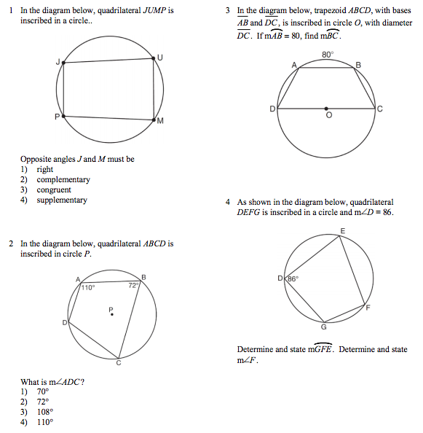

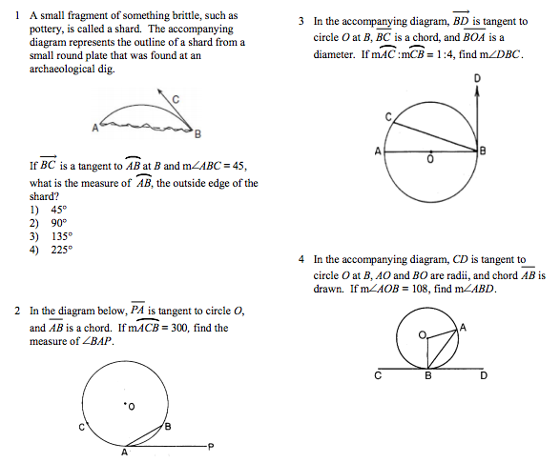 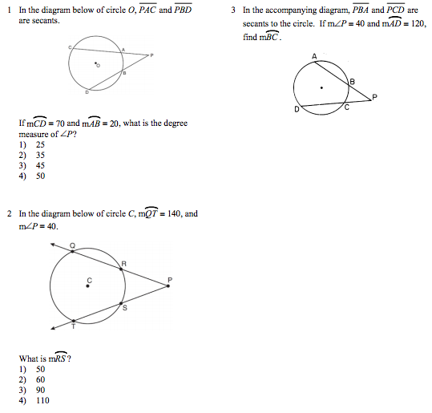

**Topic #5: Segments created in Circles**

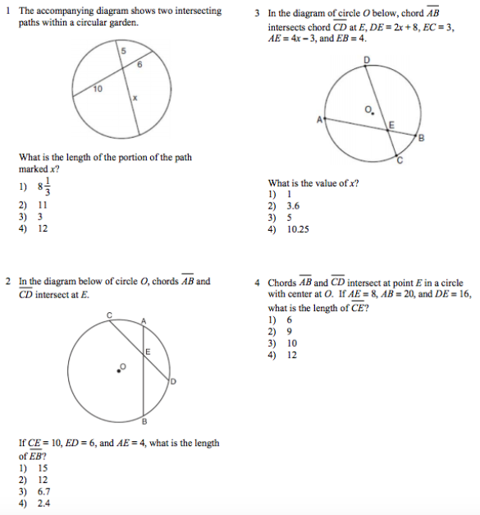 

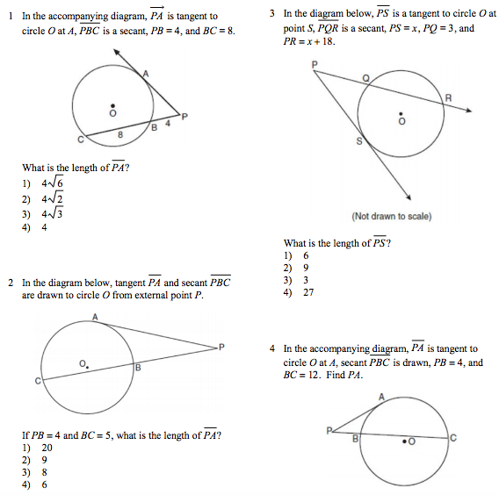

**Topic #6: Equations of Circles on the Coordinate Plane**

1. The standard equation of a circle is given below. Identify the center and the radius of the circle.

2. Write the standard equation of a circle with center at (0, - 5) given point on the circle at (4, - 2).

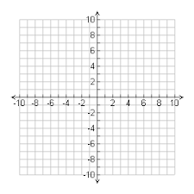

3. Find the center and radius of the circle whose equation is given below. Rewrite in standard form.   
  
http://www.softschools.com/math/calculus/images/completing_the_square_circles_img_26.png